BIT503 - Fundamentals of Information Technology
Assessment 3

Thomas Bernard
Student ID: 5142644

Part 1 & Part 2 (see Zipped website)

Part 3: Usability and accessibility
Bingelist website was created in mind of those with disabilities & others who experience difficulties online. We followed the Nielsen’s heuristics for usability guidelines (Open Polytechnic 2025) to help us build our site to ensure it is accessible for most users online. As Outlined in the Nielsen’s heuristics for usability guidelines we have targeted the following in our website:
Error Prevention
On Bingelist we enhanced the user experience so if any user fills out any incorrect information for example on the register page there will be a clear error message that pops up to tell the user of the error and how they can fix it. For example, if the user uses letters in the phone number field it would let you know it is incorrect format and let you know so you can correct it.
Aesthetic and minimalistic design
Bingelist was created with simplicity to ensure users could navigate and get relevant information quickly. We would never put any non-essential information on our website.
Recognition rather than recall
Bingelist stands out as a simple premium website with easy-to-read information and lovely, captivating posters that draws attention to the eye and makes things more memorable for users.

Flexibility and efficiency of use
Bingelist incorporates multiple options to users. To ensure this we have alt text on images so those that are using screen readers can fully understand the images. We also incorporated forms that work with a range of users especially those with low vision and those without a keyboard they can tab to each field directly.
Match between system and real world
Bingelist use simple familiar concepts that the users understand. For example, Home & Register pages that are found on most websites online with clear instructions and formats that match other sites online
Consistency and standards
Bingelist use language that is relevant to the website for example “blockbuster” and “trending.” These are terms that are used in this type of content and in real word.

Task 2: Customer and technical support
Bingelist have been created with simplicity in mind. To alter the website please follow the steps below.
Bingelist complete website is in a .zip format. You would need to extract its contents out, then you will see all the files and folders for the website.
You would see all the content including index.html register.html and trending.html. These are the pages the site has currently if you were to create a new page. It is quite simple just open any text editor for example Visual Studio Code or Notepad. You would create a new page titled for example movieshowtimes.html, the file name being something related to the theme. See screenshot below for example of the new page and the code you could use. Please make sure to follow correct HTML practises *Hint Visual Studio code is fantastic for beginners, have a play and you can create a new page for the site.
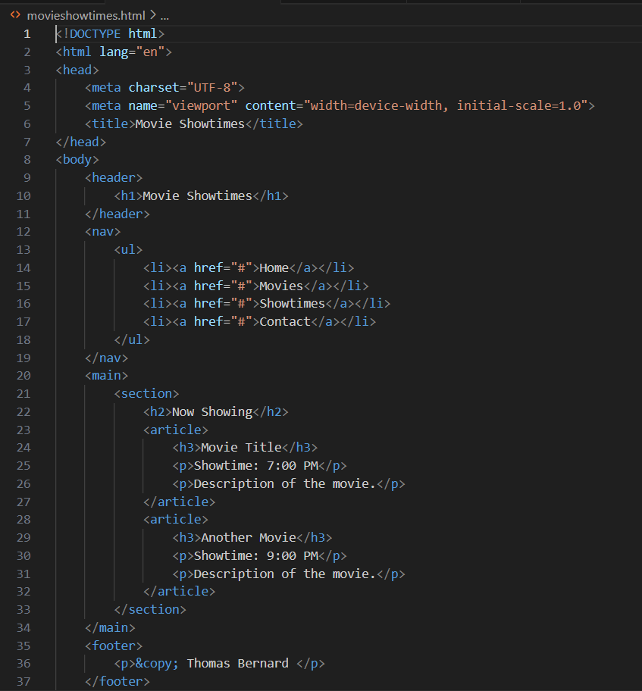

To change the YouTube, embed to another video please open Index.html as that where the YouTube embed code is located, see screenshot below.
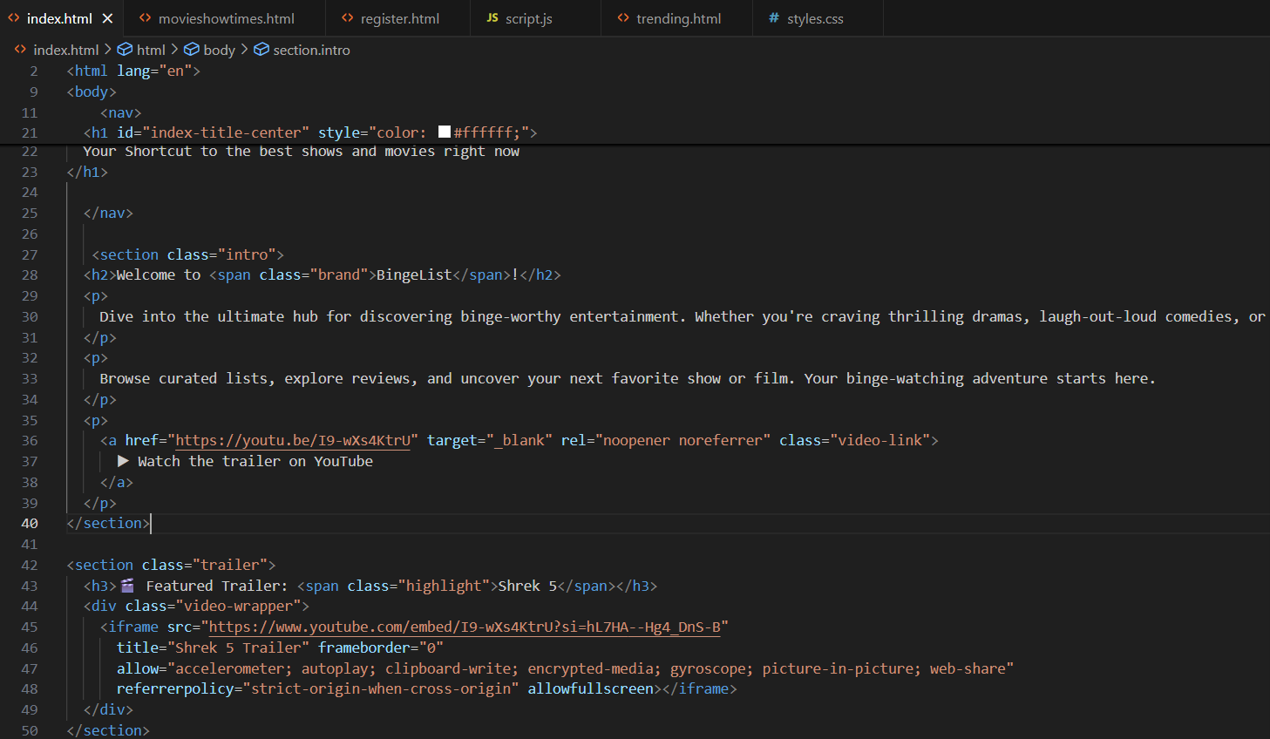

To get YouTube Embed URL so you can change it, go to youtube.com to search for your movie trailer.

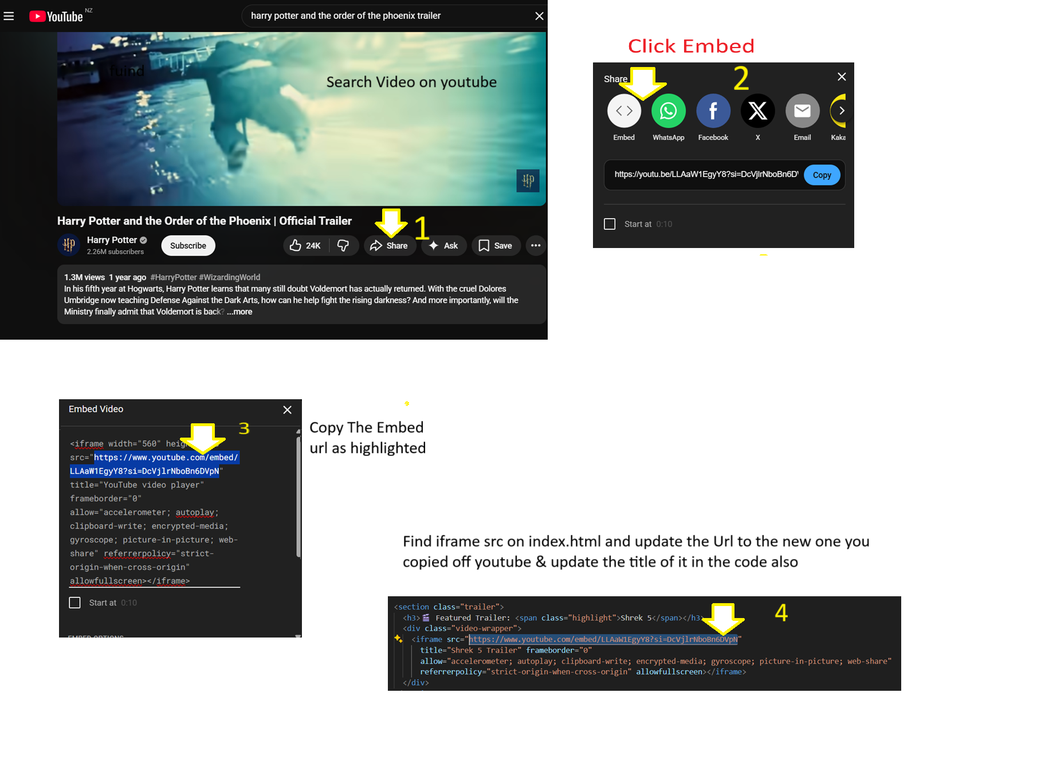
To change the YouTube URL, follow the following steps to achieve this via the website youtube.com.

Open Index.html and find the table in the code and update as per photo
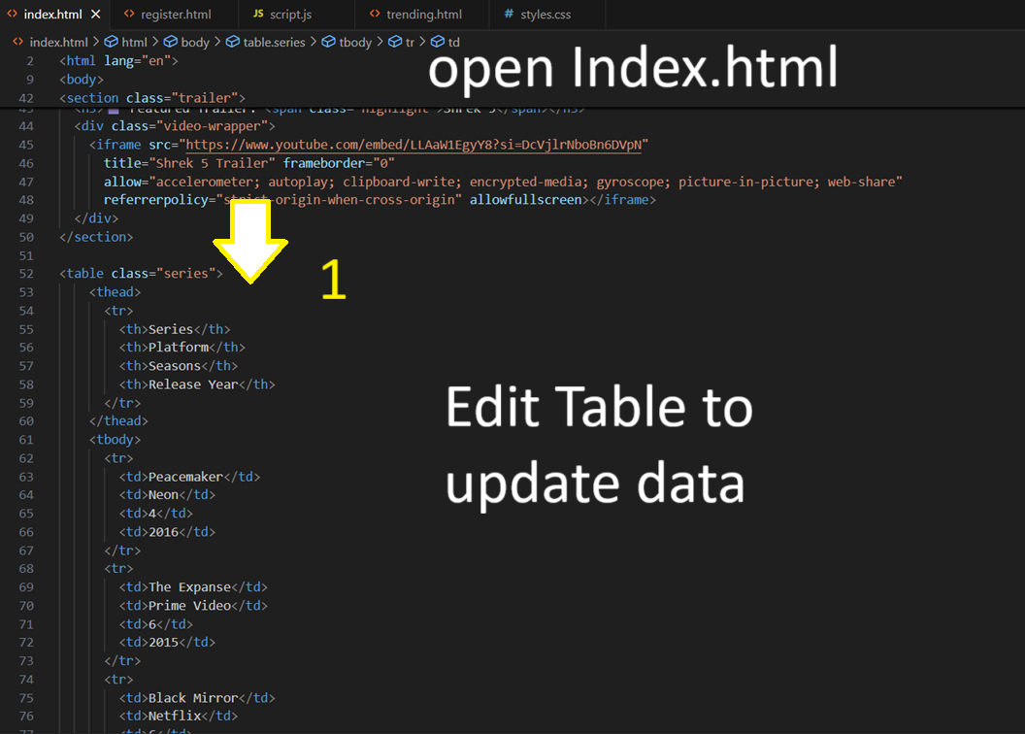

Follow the following steps to change the list to a Roman Numerals
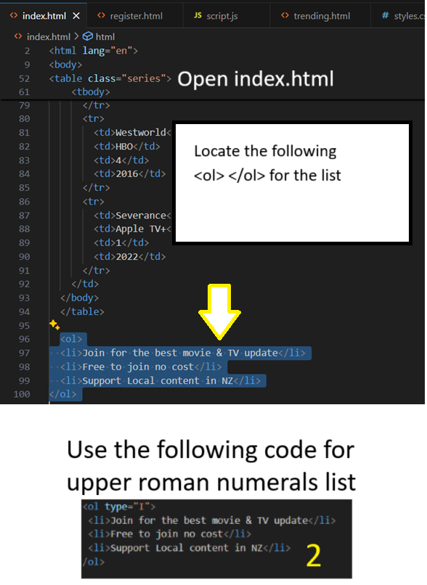
To change the Footer code on the website please navigate to footer section on all website pages, for example index.html register.html & trending.html pages and change the code to show your name and due date.
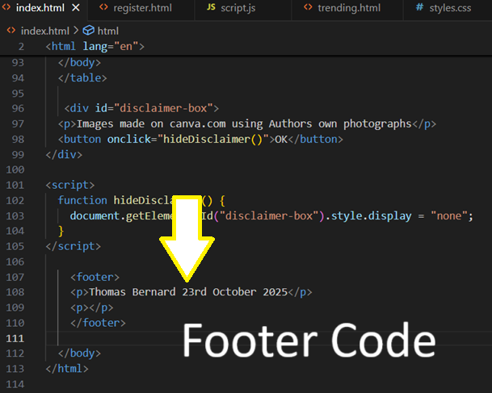

‘

References
Open Polytech (2025). BIT503 Fundamentals of Information Technology Topic 9: Web design and development Introduction to usability
Images made on canva.com using Authors own photographs.

